A Homebuyer's Guide to Atlanta Neighborhood Selection in 2021

Kristan Bhandari

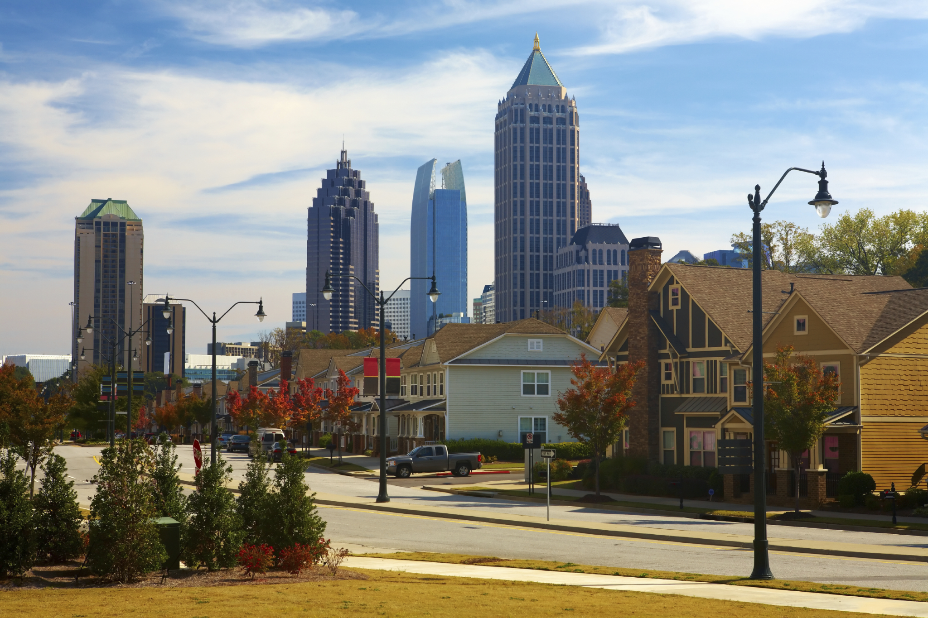

**Table of Contents**

|  |  |
| --- | --- |
| Introduction  1.1 Background  1.2 Problem  1.3 Need for Data  Data Collection  2.1 Data Sources  References |  |

# Introduction

## 1.1 Background

The COVID-19 pandemic has affected the housing market in many ways. Last year, we saw an offset buying season, with extraordinarily low inventory during the summer, and strained construction crews and a higher cost of materials meant fewer homes were being built. 2020 saw a shortage of nearly 4 million new constructions1, and it’s estimated that lumber costs have driven up the price by nearly $24k2. Factor in low mortgage rates, and a new wave of Gen-Z first-time homebuyers and Millenials looking to “trade up,” and you have a recipe for a steep increase in home pricing. While some may argue these factors don’t necessarily make this a true housing bubble, no one can deny that the current housing market does not favor buyers. In fact, this is the strongest seller’s market since 20063.

## 1.2 Problem

The largest obstacle homebuyers will run into as they identify prospective homes is highly competitive bidding. Approximately 36% of homes sold in February this year sold above asking price, which is the largest share on record3. Those who *do* sell are often looking to buy in a more affordable area, where they will be able to outbid local homebuyers. And remote work has many city-dwellers looking to the suburbs, which have comparatively lower prices, giving them the upper hand.

This is especially critical for the city of Atlanta, as housing prices vary greatly, from the affluent neighborhood of North Buckhead to the modest area of Cross Creek, to the numerous surrounding suburban communities, each with their own unique characteristics. With such a variety and so many factors to consider (schools, crime rate, popular places, etc.), it can be difficult to narrow the options and figure out the best area to buy.

## 1.3 Need for Data

It is imperative that current homebuyers choose their desired areas wisely, because when they do put in an offer, theirs will just be one of many. The goal of this analysis is to help those brave enough to take on the competitive market and take advantage of low mortgage rates to make the most educated decision possible before diving in.

# 

# **Data Collection**

## 2.1 Data Sources

In order to gain as much insight as possible into each neighborhood, the following factors will be explored:

* **Value** - determined by average price per sqft
* **Potential for appreciation** - determined by Zillow’s Home Value Forecast (ZHVF)
* **School district quality** - determined by the GA Governor’s Office of Student Achievement
* **Crime level** - determined by crime index scores from city-data.com
* **Activity level** - determined by popularity of venues in the area from data provided by Foursquare

To this end, data will be collected from the following sources:

* [Zip Codes for Atlanta (GA) Metro Area via namecensus.com](https://namecensus.com/igapo/zip_codes/metropolitan-areas/metro-alpha/Atlanta%20(GA)1.html)
* [ZILLOW/DATA via Quandl API](https://www.quandl.com/databases/ZILLOW/documentation)
* [School District-Level Data from 2019 via Georgia Governor’s Office of Student Achievement](https://schoolgrades.georgia.gov/dataset/district-level-data)
* [Crime in Georgia via City-Data.com](http://www.city-data.com/crime/crime-Georgia.html)
* [Popular Venues & Venue Details via Foursquare API](https://developer.foursquare.com/docs/api-reference/venues/explore/)

# References

1. Hale, Danielle, et al. “2021 Housing Market Predictions and Forecast.” *Realtor.com Economic Research*, Realtor.com, 17 Dec. 2020, www.realtor.com/research/2021-national-housing-forecast/.
2. Glaze, Tim. “Insane Lumber Prices Mean New Homes Cost $24K More.” *HousingWire*, HousingWire, 19 Mar. 2021, www.housingwire.com/articles/insane-lumber-prices-mean-new-homes-cost-24k-more/.
3. Glaze, Tim. “Buyers Are Overpaying, but Are There Signs of a Bubble?” *HousingWire*, HousingWire, 25 Mar. 2021, 4:24pm, www.housingwire.com/articles/buyers-are-overpaying-but-are-there-signs-of-a-housing-bubble/.